*Naida Demirović*

*ErmalBizhuta*

*Agustin Velasco*

**Innovation & Creativity Management (INO402)**

***INL1: Innovation processes and Entrepreneurship***

Innovation case report - Vodafone Albania

November 2017



*Company intruduction and operating structure*

In this assignment, the working group should carry out a study on the processes of innovation and entrepreneurship, thus it is expected that it will be correctly understood what innovation processes and their environment consist of.To do this, the working group will choose a company to contact and combine it with the literature information.

Social entrepreneurship is a rather confusing variety of types of entrepreneurial activity with a social mission. There are a number of different efforts at definition. An early clarification of a leading researcher as a starting point to describe it is: Social entrepreneurship is about innovative, market-oriented approaches underpinned by a passion for social equity and environmental sustainability (Dees, 1998). Social entrepreneurship is a varied blend of thespirit of enterprise and the spirit of social concern. An early and leading social entrepreneur is Bill Drayton originator of the Ashoka organization of Fellows . The task of this new breed of entrepreneurs is according to Drayton to reintegrate the business and the citizen sectors. For him, social entrepreneurs are those who “recognize when a part of society is stuck and provide new ways to get it unstuck.

The case we chose to write about is Vodafone Albania, we chose Vodafone because they did something good for society, not just because of profit. It is a part of Vodafone Group Plc, which is a global communication leader. Our contact in this case was the Director of Marketing, which one of the group’s members happened to have had several connections in the past.

Vodafone Albania can be taken as the perfect example of an innovation-drived company. This report focuses on the information given from our contact regarding the company’s innovation models and process.

Vodafone was introduced in Albanian market in August 2001 through one of the fastest network rollouts in the world, building in the experience of Vodafone networks all over the world and making Albania catch up with the latest communication technologies in the same time with the rest of the world. The companywas the first operator that introduced the 3G technology in Albania in January 2011. Currently Vodafone covers 99% of Albania’s population with its 3G network, and over 78% of it with the 4G network. It offers for its 2 million customers in Albania a wide range of services of highest quality including voice and data communication ensuring that customers use the best telecommunications network and benefit from novelties.

Vodafone Albania has a network of 139 shops across the whole country providing services 7 days a week. Vodafone Albania shops offer products and services, handsets and accessories and technical assistance. The Customer Care Service of Vodafone Albania responds to the concerns of clients 24 hours a day and 7 days a week.

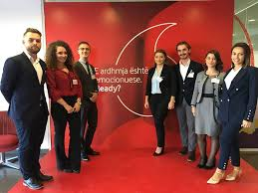

Vodafone Albania is one of the leader companies in the Albanian market providing a significant contribution to the Albanian economy and innovation field.  The company has recruited the best employees and the best expertise in the country and has professionally trained its employees, being the employer of choice in the country.

The company is divided in several departments and each department has sectors which serve different functions. Staff members report to Managers, Managers report to Heads of sectors and Head of sectors report to Directors which are in charge of the whole Department.

Corporate Responsibility is a vital part of Vodafone’s philosophy. The company pays special attention to the environment protection policies and energy saving, reduction of CO2 emissions and recycling of technology devices and accessories, in a country where enviromental-saving methodologies do not get implemented that often. The company supports and is part of initiatives aiming environment protection.

Vodafone Albania also encouraged the establishment of the Vodafone Albania Foundation – part of the Vodafone Foundations Group, present across the world. Since its establishment in 2008, Vodafone Albania Foundation has been a significant player in supporting a large projects on social care investing over ALL 60,000,000 (EUR 450,000) every year to support and meet the needs of local community, environment protection youth innovation and entrepreneurship and promoting the national culture and heritage.

Finally, we can say that Vodafone was successful in Albania because they not only copied the idea of Vodafone's major outlets in Europe, but also focused on the needs of the Albanian people. The following points demonstrate this:

1. Customer satisfaction by rapid delivery of useful software

2. Welcome changing requirements, even late in development

3. Working software is delivered frequently (weeks rather than months)

4. Working software is the principal measure of progress

5. Sustainable development, able to maintain a constant pace

6. Close, daily cooperation between business people and developers

7. Face-to-face conversation is the best form of communication (co-location)

8. Projects are built around motivated individuals, who should be trusted

9. Continuous attention to technical excellence and good design

10. Simplicity—the art of maximizing the amount of work not done—is essential

11. Self-organizing teams

12. Regular adaptation to changing circumstances

AGILE MANIFESTO (2001)

*Innovation cases and processes*

Overall, the questions we managed to ask and get an answer from our contact, were regarding the character of the innovation processes, who were the most crucial people that played a role in the process and some information about their specific tasks. For businesses like Vodafone in order to successfully innovate, they need to install the strategies that best fit their needs and goals.

We asked our contact to describe us their company’s service/product innovation processes and how they operate in these terms. What he explained us was :

“For us, innovation process is the process which facilitates innovation. The process of innovation involves search, exploration and synthesis with actual methodologies, cycles of divergent thinking and convergence.One of the keys to any successful business is being able to come up with new ideas to keep operations, products and services fresh. The process of bringing those ideas to reality is called innovation. While thinking up new ideas is one step of the process, businesses in a field like ours have a much greater task in trying to turn that into an actual product or service that will benefit customers.

In the vast sea of innovation, companies that take the largest risk, close the biggest gaps and identify the newest opportunities are seen as true innovators and leaders by their consumers and peers. These true innovators are setting themselves apart from any and all competition.“

– ***Vodafone Albania***

So what the company tells us is that Ideas are indeed the seeds of innovation; but it takes a lot of work to come up with functional and successful ideas, so they don’t start by collecting raw ideas. Instead, they tell us that innovation is a core element of the organizations’ strategy, so they have to start the innovation process itself with strategic thinking to assure that the outputs of innovation are fully aligned with their strategic intent.

*A brief description of the innovation process.*

**1. Reaching across business units for innovative ideas**

* A team is selected with members of the marketing, technology and legal department etc. to work on the project (so that the new product/service is according to company’s policies, can be marketed and can be initiated by the technical team)

**2. Engage customers in product development (i.e via surveys)**

**3. Look to disruptive technologies to faster innovation**

* Look here is a market need for an innovative product or there is a process which needs to be improved in innovative ways.

**4. Learn from previous mistakes**

**5. Make the current innovation project a priority.**

- Workshops and brainstorming sessions

Example: Yearly Innovation Workshop (teams with members from different departments, compete with one another with an innovative idea on a new product/service, the best idea wins and is developed and implemented) (there are other similar projects)

**6. Tactical approach to the product’s launch**

* Launch of the product/service

One analytical data the company provided us with was the effects of their latest big project “Project Spring”, which was one of the biggest innovative moves done by the company in terms of data technologies and its development.

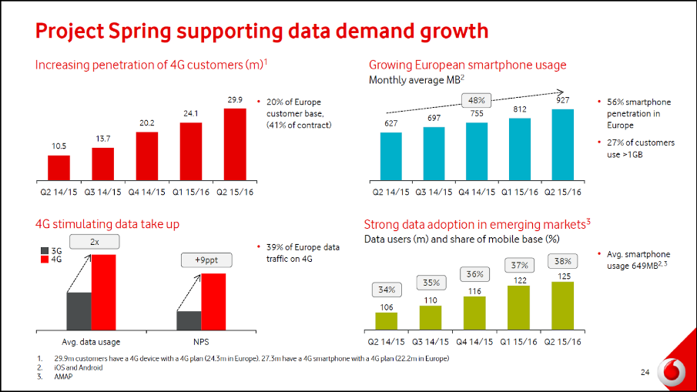

As the graphics show, what the company saw, was a growing demand in the customers’ need of a stronger, more reliable and faster service for communication technologies. So, they acquire Ono technologies and co-operate with another company in the sector, Capex synergies. Because of this big movement, Vodafone’s revenue dropped to 3 percent in 2016 only to see an unimaginable rise in 2017 by 4,7 percent. This was because the quality of the technology used by the company totally transformed, by enhancing so the customers’ experience and enabling the company to expand its Enterprise services.

To give us more information about the character of this big innovation process, our contact adds:

One of the main pillars of Vodafone’s way of working is Innovation Hungry.Innovation Hungry is about creating and delivering new products, services and ways of working, being externally focused and providing fresh thinking. We work in a climate that promotes innovation and risk-tasking in the pursuit of our commercial objectives – not at the expense of them. We don’t tend to let our systems and actual resources stand in the way of innovation and share our learnings and mistakes to help others in the development of new ways of working. This was also the case of the “Project Spring”; we did not have the specific technology which was needed, but indeed, we still took the risk.

We see that the company is very innovation-friendly and totally not afraid of throwing itself in new risky-technologies in the vast market of mobile communications. One of the good methods in the company’s innovation process is always using the customers’ feedback in the early steps of the projects. Since many of the investments are made in early stages of the innovation process, it is very important to use indicators as customer feedback to also further develop the innovative activity over time.Telecommunication industry is very agile and competitive so the need for innovative offers, services, operations and ways of working is very important. To stay competitive, there is continuous need to innovate.

*Driving actors in innovation processes*

The company is made of several driving actors which play a very important role in the company’s innovation process.

We came to conclusion that some of the key players who are present within the organization are:

* **Creative thinker** – producing new and original ideas
* **Innovator** – brings new products/services to the market or changes existing ones.
* **Inventor** – produces new and commercial ideas.
* **Entrepreneur** – conceives of or receives ideas and translates them into business reality toexploit a market opportunity.
* **Intrapreneur** – responsible for innovation within an organization.

It is important to notice that the role of a well-functioning management team in the company is evaluated as the most important indicator for the innovation process.

Vodafone tells us that they always try to get employees encouraged to bring new ways of working and introduce innovative ideas. When the old way is not working anymore, new ways are introduced and changes in the working environment are a very common thing which employees alsoget used to.

The company’s other players and investors also focus extensively on the property of the product, process or service that is expected to be derived from the innovation activity.

In this part, uniqueness and scalabilityplay a central role. Without these components inplace, the resulting prospects (such as earnings and profits) are not fixed and secured.